| **Test Name** | | Update a Medication Type Record | | | |
| --- | --- | --- | --- | --- | --- |
| **Use Case Tested:** | | Use Case – Update a Medication Type Record | | | |
| **Test Description:** | | User finds a record entered for a Medication Type  User navigates to Search tab and selects Search Medication Types, or selects Search Medication Types button from welcome page  User is presented with a list of medication type records  User searches for a medication type using the ID or Medication Type fields  User selects record  User amends fields as required  User submits record | | | |
| **Pre-conditions** | | User must be logged in as an administrator  Medication Type records must exist | | | |
| **Post-conditions** | | The database is successfully updated with the new data for the Medication Type. | | | |
| **Notes:** | |  | | | |
| **Result (Pass/Fail/Warning/Incomplete)** | |  | | | |
|  | **TEST STEP** | | **EXPECTED TEST RESULTS** | P | F |
|  | User selects “Search > Search Medication Types” from the menu bar or selects Search Medication Types button on Admin Home page | | A list of Medication Type records is returned – using tab  A list of Medication Type records is returned – using button  *Screenshots available on UAT for Search Medication Types* | X  X |  |
|  | User enters a search for a Medication Type record | | Records meeting criteria are returned | X |  |
|  | User changes Medication Type | | Input does not show error | X |  |

|  |  |  |  |  |  |
| --- | --- | --- | --- | --- | --- |
| **Test Data Table** | | | | | |
|  | **1** | **2** | **3** | **4** | **5** |
| Test – 1 | Search = New | Change to: Cream |  |  |  |
| Test – |  |  |  |  |  |
| Test – |  |  |  |  |  |
|  |  |  |  |  |  |

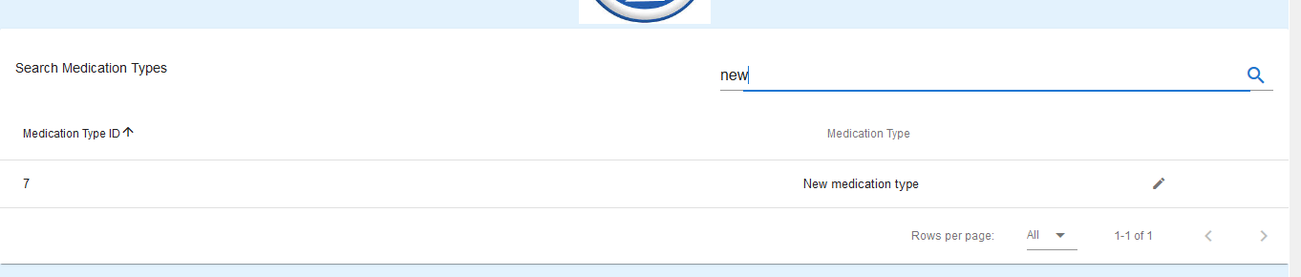

Figure 1: Search results for “new” – Brings up ID 7

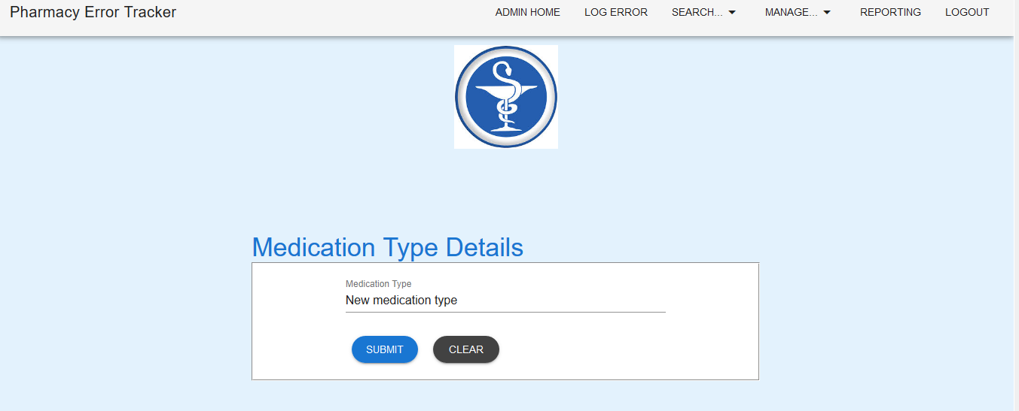

Figure 2: Medication Type loaded into Medication Type Details

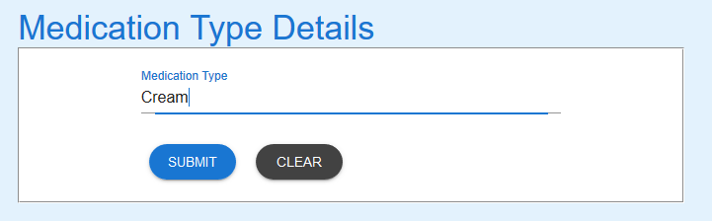

Figure 3: Medication Type updated

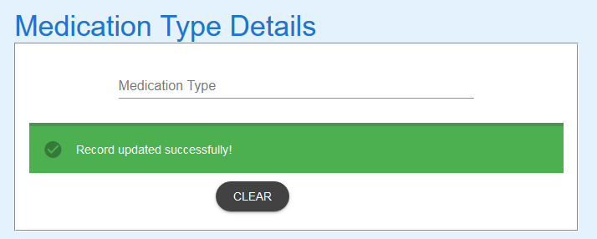

Figure 4:Record submitted. Success message received

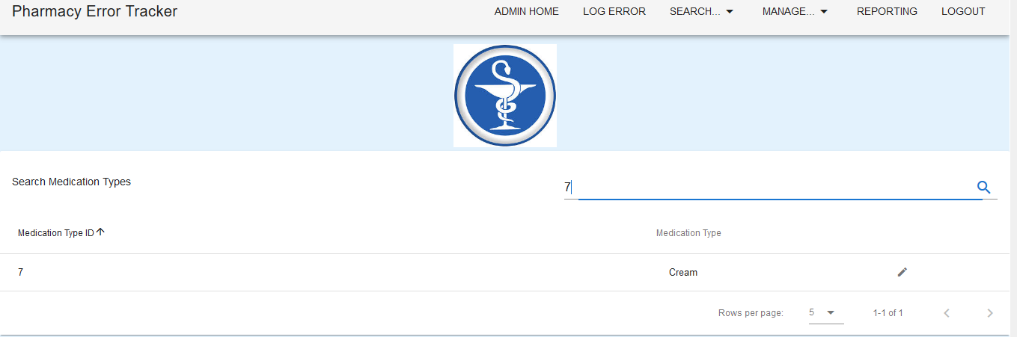

Figure 5: New search for “7” shows ID 7 has been updated as expected

EXPECTED ERROR MESSAGES:

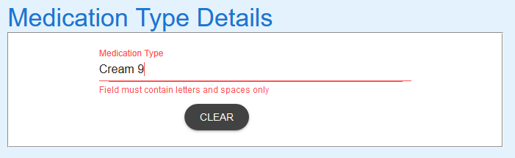

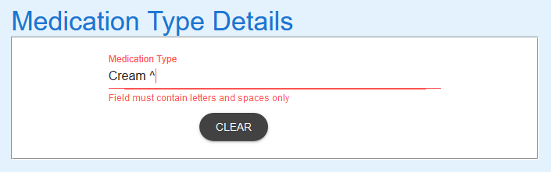

Figure 6: Using a character other than letters or spaces (Expected)

EXPECTED BEHAVIOUR

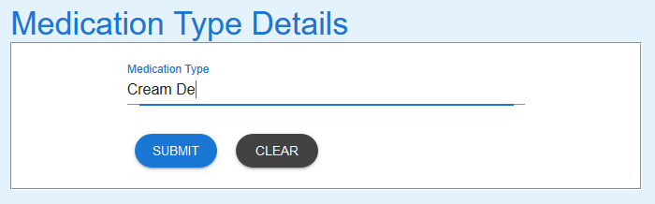

Figure 7: Using letters or spaces doesn't cause errors – Expected

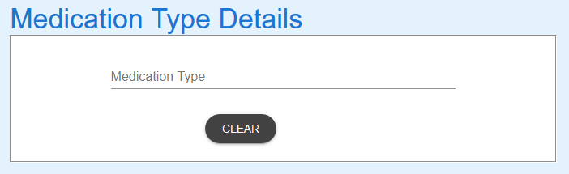

Figure 8: Selecting "Clear" caused form to be cleared – Expected



Figure 9: Change Medication Type - Try - to Cream

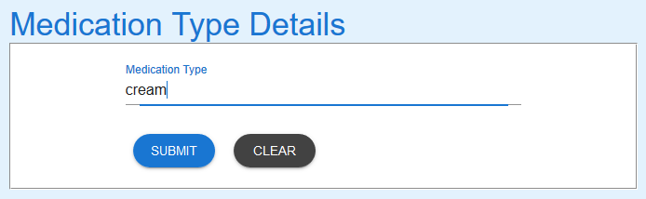

Figure 10: Medication type changed

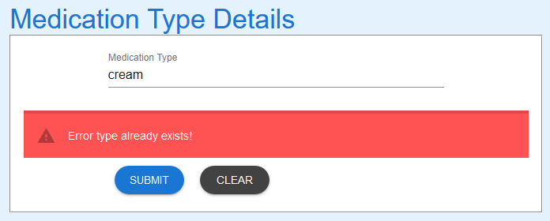

Figure 11: Record exists - Error message expected

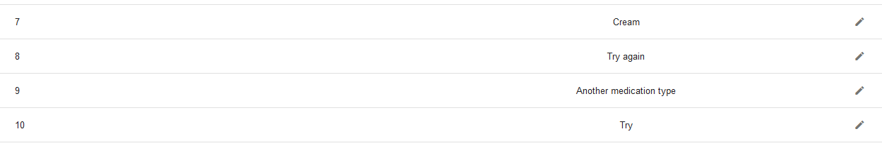

Figure 12: No change to database - Expected